Guidelines for the Creation of the

Internal Quality Assurance Cell (IQAC)

and Submission of Annual Quality Assurance Report (AQAR) in Accredited Institutions
(Revised in October 2013)



NATIONAL ASSESSMENT AND ACCREDITATION COUNCIL
An Autonomous Institution of the University Grants Commission
P. O. Box. No. 1075, Opp: NLSIU, Nagarbhavi, Bangalore - 560 072 India

NAAC

VISION

To make quality the defining element of higher education in India through a combination of self and external quality evaluation, promotion and sustenance initiatives.

MISSION

- To arrange for periodic assessment and accreditation of institutions of higher education or units thereof, or specific academic programmes or projects;

- To stimulate the academic environment for promotion of quality of teaching-learning and research in higher education institutions;

- To encourage self-evaluation, accountability, autonomy and innovations in higher education;

- To undertake quality-related research studies, consultancy and training programmes, and

- To collaborate with other stakeholders of higher education for quality evaluation, promotion and sustenance.

Value Framework
To promote the following core values among the HEIs of the country:
- Contributing to National Development
- Fostering Global Competencies among Students
- Inculcating a Value System among Students
- Promoting the Use of Technology
- Quest for Excellence

Contents

Page Nos.
- Introduction ...... 4
- Objective ...... 4
- Strategies ...... 4
- Functions ...... 5
- Benefits ...... 5
- Composition of the IQAC ...... 5
- The role of coordinator ...... 6
- Operational Features of the IQAC ...... 6
- Monitoring Mechanism ...... 7
- The Annual Quality Assurance Report (AQAR) of the IQAC ...... 8

Part – A
11. Details of the Institution ...... 9
12. IQAC Composition and Activities ...... 12
Part – B
13. Criterion – I: Curricular Aspects ...... 14
14. Criterion – II: Teaching, Learning and Evaluation ...... 15
15. Criterion – III: Research, Consultancy and Extension ...... 17
16. Criterion – IV: Infrastructure and Learning Resources ...... 20
17. Criterion – V: Student Support and Progression ...... 21
18. Criterion – VI: Governance, Leadership and Management ...... 24
19. Criterion – VII: Innovations and Best Practices ...... 27
20. Abbreviations ...... 29

___________________________
Document revised by: Dr. Ganesh Hegde, Assistant Adviser and B. S. Ponmudiraj, Assistant Adviser, NAAC
Guidelines for the Creation of the

Internal Quality Assurance Cell (IQAC)

and Submission of Annual Quality Assurance Report (AQAR)

in Accredited Institutions

Introduction
In pursuance of its Action Plan for performance evaluation, assessment and accreditation and quality up-gradation of institutions of higher education, the National Assessment and Accreditation Council (NAAC), Bangalore proposes that every accredited institution should establish an Internal Quality Assurance Cell (IQAC) as a post-accreditation quality sustenance measure. Since quality enhancement is a continuous process, the IQAC will become a part of the institution’s system and work towards realisation of the goals of quality enhancement and sustenance. The prime task of the IQAC is to develop a system for conscious, consistent and catalytic improvement in the overall performance of institutions. For this, during the post-accreditation period, it will channelize all efforts and measures of the institution towards promoting its holistic academic excellence.
The guidelines provided in the following pages will guide and facilitate the institution in the creation and operation of the Internal Quality Assurance Cell (IQAC). The work of the IQAC is the first step towards internalization and institutionalization of quality enhancement initiatives. Its success depends upon the sense of belongingness and participation it can inculcate in all the constituents of the institution. It will not be yet another hierarchical structure or a record-keeping exercise in the institution. It will be a facilitative and participative voluntary system/unit/organ of the institution. It has the potential to become a vehicle for ushering in quality enhancement by working out planned interventionist strategies to remove deficiencies and enhance quality like the “Quality Circles” in industries.

Objective
The primary aim of IQAC is

- To develop a system for conscious, consistent and catalytic action to improve the academic and administrative performance of the institution.
- To promote measures for institutional functioning towards quality enhancement through internalization of quality culture and institutionalization of best practices.

Strategies
IQAC shall evolve mechanisms and procedures for

a) Ensuring timely, efficient and progressive performance of academic, administrative and financial tasks;
b) The relevance and quality of academic and research programmes;
c) Equitable access to and affordability of academic programmes for various sections of society;
d) Optimization and integration of modern methods of teaching and learning;
e) The credibility of evaluation procedures;
f) Ensuring the adequacy, maintenance and proper allocation of support structure and services;
g) Sharing of research findings and networking with other institutions in India and abroad.

Functions

Some of the functions expected of the IQAC are:

- Development and application of quality benchmarks/parameters for various academic and administrative activities of the institution;
- Facilitating the creation of a learner-centric environment conducive to quality education and faculty maturation to adopt the required knowledge and technology for participatory teaching and learning process;
- Arrangement for feedback response from students, parents and other stakeholders on quality-related institutional processes;
d) Dissemination of information on various quality parameters of higher education;
e) Organization of inter and intra institutional workshops, seminars on quality related themes and promotion of quality circles;
f) Documentation of the various programmes/activities leading to quality improvement;
g) Acting as a nodal agency of the Institution for coordinating quality-related activities, including adoption and dissemination of best practices;
h) Development and maintenance of institutional database through MIS for the purpose of maintaining /enhancing the institutional quality;
i) Development of Quality Culture in the institution;
j) Preparation of the Annual Quality Assurance Report (AQAR) as per guidelines and parameters of NAAC, to be submitted to NAAC.

Benefits
IQAC will facilitate / contribute
- Ensure heightened level of clarity and focus in institutional functioning towards quality enhancement;
- Ensure internalization of the quality culture;
b) Ensure enhancement and coordination among various activities of the institution and institutionalize all good practices;
c) Provide a sound basis for decision-making to improve institutional functioning;
d) Act as a dynamic system for quality changes in HEIs;
e) Build an organised methodology of documentation and internal communication.

Composition of the IQAC
IQAC may be constituted in every institution under the Chairmanship of the Head of the institution with heads of important academic and administrative units and a few teachers and a few distinguished educationists and representatives of local management and stakeholders.

The composition of the IQAC may be as follows:
1. Chairperson: Head of the Institution
2. A few senior administrative officers
3. Three to eight teachers
4. One member from the Management
5. One/two nominees from local society, Students and Alumni
6. One/two nominees from Employers /Industrialists/stakeholders
7. One of the senior teachers as the coordinator/Director of the IQAC

The composition of the IQAC will depend on the size and complexity of the institution. It helps the institutions in planning and monitoring. IQAC also gives stakeholders or beneficiaries a cross-sectional participation in the institution’s quality enhancement activities. The guidelines given here are only indicative and will help the institutions for quality sustenance activities.
The membership of such nominated members shall be for a period of two years. The IQAC should meet at least once in every quarter. The quorum for the meeting shall be two-third of the total number of members. The agenda, minutes and Action Taken Reports are to be documented with official signatures and maintained electronically in a retrievable format.
It is necessary for the members of the IQAC to shoulder the responsibilities of generating and promoting awareness in the institution and to devote time for working out the procedural details. While selecting these members several precautions need to be taken. A few of them are listed below:
- It is advisable to choose persons from various backgrounds who have earned respect for integrity and excellence in their teaching and research. Moreover, they should be aware of the ground realities of the institutional environment. They should be known for their commitment to improving the quality of teaching and learning.
- It would be appropriate to choose as senior administrators, persons in charge of institutional services such as library, computer center, estate, student welfare, administration, academic tasks, examination and planning and development.
- The management representative should be a person who is aware of the institution’s objectives, limitations and strengths and is committed to its improvement. The local society representatives should be of high social standing and should have made significant contributions to society and in particular to education.

The role of coordinator
The role of the coordinator of the IQAC is crucial in ensuring the effective functioning of all the members. The coordinator of the IQAC may be a senior person with expertise in quality aspects. She/he may be a full-time functionary or, to start with, she/he may be a senior academic /administrator entrusted with the IQAC as an additional responsibility. Secretarial assistance may be facilitated by the administration. It is preferable that the coordinator may have sound knowledge about the computer, its various functions and usage for effective communication.

Operational Features of the IQAC
Quality assurance is a by-product of ongoing efforts to define the objectives of an institution, to have a work plan to achieve them and to specify the checks and balances to evaluate the degree to which each of the tasks is fulfilled. Hence devotion and commitment to improvement rather than mere institutional control is the basis for devising procedures and instruments for assuring quality. The right balance between the health and growth of an institution needs to be struck. The IQAC has to ensure that whatever is done in the institution for “education” is done efficiently and effectively with high standards. In order to do this, the IQAC will have to first establish procedures and modalities to collect data and information on various aspects of institutional functioning.

The coordinator of the IQAC and the secretary will have a major role in implementing these functions. The IQAC may derive major support from the already existing units and mechanisms that contribute to the functions listed above. The operational features and functions discussed so far are broad-based to facilitate institutions towards academic excellence and institutions may adapt them to their specific needs.

Monitoring Mechanism
The institutions need to submit yearly the Annual Quality Assurance Report (AQAR) to NAAC. A functional Internal Quality Assurance Cell (IQAC) and timely submission of Annual Quality Assurance Reports (AQARs) are the Minimum Institutional Requirements (MIR) to volunteer for second, third or subsequent cycle’s accreditation. During the institutional visit the NAAC peer teams will interact with the IQACs to know the progress, functioning as well quality sustenance initiatives undertaken by them.

The Annual Quality Assurance Reports (AQAR) may be the part of the Annual Report. The AQAR shall be approved by the statutory bodies of the HEIs (such as Syndicate, Governing Council/Board) for the follow up action for necessary quality enhancement measures.

The Higher Education Institutions (HEI) shall submit the AQAR regularly to NAAC. The IQACs may create its exclusive window on its institutional website and regularly upload/ report on its activities, as well as for hosting the AQAR.

The NAAC Accredited institutions need to submit only the soft copy as word file (.doc/.docx) through e-mail (naac.aqar@gmail.com). The file name needs to be submitted with Track ID of the institution and College Name. For example MHCOGN16601-Samudra Arts and Science College, Taliamegu-Maharashtra.doc. The Higher Education Institutions need not submit the printed/hard copy to NAAC. The acknowledgements would be sent to the institutions through e-mail.

The Annual Quality Assurance Report (AQAR) of the IQAC

(2012-2013)

All NAAC accredited institutions will submit an annual self-reviewed progress report to NAAC, through its IQAC. The report is to detail the tangible results achieved in key areas, specifically identified by the institutional IQAC at the beginning of the academic year. The AQAR will detail the results of the perspective plan worked out by the IQAC. (Note: The AQAR period would be the Academic Year. For example, July 1, 2012 to June 30, 2013)

Part – A
1. Details of the Institution
K.R.P.College of Education
1.1 Name of the Institution
Pachampalayam
1.2 Address Line 1
Sankari West
Address Line 2
Namakkal District
City/Town
Tamilnadu
State
637303
Pin Code
krpinstitutions@gmail.com
Institution e-mail address
04283 - 254277

Contact Nos.
Dr.D.Ramesha Naik
Name of the Head of the Institution:
04283 - 254277
Tel. No. with STD Code:
09449201051
Mobile:
Mr.C.Shankar
Name of the IQAC Co-ordinator:
09952366103
Mobile:
Krpiqac2012@gmail.com
IQAC e-mail address:

1.3 NAAC Track ID (For ex. MHCOGN 18879) 12353
www.krpinstitution.org
1.4 Website address:
www.krpinstitution.org/AQAR2012-13
-
Web-link of the AQAR:
For ex. http://www.ladykeanecollege.edu.in/AQAR201213.doc

1.5 Accreditation Details
Sl. No. | Cycle | Grade | CGPA | Year of Accreditation | Validity Period
1 | 1st Cycle | B | 2.75 | 2013 | 5 Years
2 | 2nd Cycle | - | - | - | -
3 | 3rd Cycle | - | - | - | -
4 | 4th Cycle | - | - | - | -

1.6 Date of Establishment of IQAC : DD/MM/YYYY
13.01.2012

2012 – 13
1.7 AQAR for the year (for example 2010-11)

1.8 Details of the previous year’s AQAR submitted to NAAC after the latest Assessment and Accreditation by NAAC ((for example AQAR 2010-11submitted to NAAC on 12-10-2011)
- AQAR ______________________NIL __________________ (DD/MM/YYYY)4
- AQAR__________________NIL ________________________ (DD/MM/YYYY)
- AQAR__________________ NIL_______________________ (DD/MM/YYYY)
- AQAR__________________NIL _______________________ (DD/MM/YYYY)
1.9 Institutional Status
---
-
-
-
University State Central Deemed Private
√

Affiliated College Yes No
Constituent College Yes No

Autonomous college of UGC Yes No

Regulatory Agency approved Institution Yes No
(eg. AICTE, BCI, MCI, PCI, NCI)
√

Type of Institution Co-education Men Women

√

Urban Rural Tribal

Financial Status Grant-in-aid UGC 2(f) UGC 12B

Grant-in-aid + Self Financing Totally Self-financing

√

1.10 Type of Faculty/Programme

Arts Science Commerce Law PEI (Phys Edu)

TEI (Edu) Engineering Health Science Management
√

NIL
Others (Specify)
TAMILNADU TEACHERS EDUCATION UNIVERSITY, CHENNAI-05
1.11 Name of the Affiliating University (for the Colleges)

1.12 Special status conferred by Central/ State Government-- UGC/CSIR/DST/DBT/ICMR etc
Nil
Autonomy by State/Central Govt. / University
-
University with Potential for Excellence UGC-CPE
-
-
-
DST Star Scheme UGC-CE
-
-
UGC-Special Assistance Programme DST-FIST
-
-
UGC-Innovative PG programmes Any other (Specify)
-
UGC-COP Programmes

2. IQAC Composition and Activities
3
2.1 No. of Teachers
2
2.2 No. of Administrative/Technical staff
NIL
2.3 No. of students
2.4 No. of Management representatives
1
1
2.5 No. of Alumni
2.6 No. of any other stakeholder and
NIL
community representatives
1
2.7 No. of Employers/ Industrialists
1
2.8 No. of other External Experts
2.9 Total No. of members
1
]’
loiouyr
9
2.10 No. of IQAC meetings held
1
2
2.11 No. of meetings with various stakeholders: No. Faculty
2
1
1
Non-Teaching Staff Students Alumni Others
---
√

2.12 Has IQAC received any funding from UGC during the year? Yes No
-
If yes, mention the amount
2.13 Seminars and Conferences (only quality related)
(i) No. of Seminars/Conferences/ Workshops/Symposia organized by the IQAC
-
-
-
-
-
Total Nos. International National State Institution Level
-
(ii) Themes
2.14 Significant Activities and contributions made by IQAC
Institutional project has been made

2.15 Plan of Action by IQAC/Outcome
The plan of action chalked out by the IQAC in the beginning of the year towards quality
Enhancement and the outcome achieved by the end of the year *

Plan of Action | Achievements
Innovative practices of teaching and learning | Implemented
* Attach the Academic Calendar of the year as Annexure-I
√

-
2.15 Whether the AQAR was placed in statutory body Yes No
√

-
-
Management Syndicate Any other body

Provide the details of the action taken
The AQAR was placed at the management committee and discussed.

Part – B
Criterion – I

1. Curricular Aspects

1.1 Details about Academic Programmes
Level of the Programme | Number of existing Programmes | Number of programmes added during the year | Number of self-financing programmes | Number of value added / Career Oriented programmes
PhD | - | - | - | -
PG | 1 | - | - | -
UG | 1 | - | - | -
PG Diploma | - | - | - | -
Advanced Diploma | - | - | - | -
Diploma | - | - | - | -
Certificate | - | - | - | -
Others | - | - | - | -
Total | 2 | - | - | -

Interdisciplinary | - | - | - | -
Innovative | - | - | - | -

1.2 (i) Flexibility of the Curriculum: CBCS/Core/Elective option / Open options
(ii) Pattern of programmes:
Pattern | Number of programmes
Semester | -
Trimester | -
Annual | 1

√

√

√

√

1.3 Feedback from stakeholders* Alumni Parents Employers Students
(On all aspects)

√

Mode of feedback : Online Manual Co-operating schools (for PEI)
*Please provide an analysis of the feedback in the Annexure-II

1.4 Whether there is any revision/update of regulation or syllabi, if yes, mention their salient aspects.
Yes, Updated as Per University regulations, content improved.

1.5 Any new Department/Centre introduced during the year. If yes, give details.
No

Criterion – II
2. Teaching, Learning and Evaluation
2.1 Total No. of permanent faculty
Total | Asst. Professors | Associate Professors | Professors | Others
13 | 10 | 1 | 1 | 1(PRINCIPAL)
3
2.2 No. of permanent faculty with Ph.D.
2.3 No. of Faculty Positions Recruited (R) and Vacant (V) during the year
Asst. Professors |  | Associate Professors |  | Professors |  | Others |  | Total
R | V | R | V | R | V | R | V | R | V
2 | - | 1 | - | - | - | - | - | 3 | -
1
1
NIL
2.4 No. of Guest and Visiting faculty and Temporary faculty

2.5 Faculty participation in conferences and symposia:

No. of Faculty | International level | National level | State level
Attended Seminars/ Workshops | 2 | 1 | -
Presented papers | 2 | 1 | -
Resource Persons | - | - | -

2.6 Innovative processes adopted by the institution in Teaching and Learning:
Power Point Presentation, Smart class, Field based Activities

180
2.7 Total No. of actual teaching days
during this academic year
2.8 Examination/ Evaluation Reforms initiated by
NIL
the Institution (for example: Open Book Examination, Bar Coding,
Double Valuation, Photocopy, Online Multiple Choice Questions)

NIL
-
2.9 No. of faculty members involved in curriculum
restructuring/revision/syllabus development
as member of Board of Study/Faculty/Curriculum Development workshop
95.00 %
2.10 Average percentage of attendance of students

2.11 Course/Programme wise
distribution of pass percentage :

Title of the Programme | Total no. of students appeared | Division
Title of the Programme | Total no. of students appeared | Distinction % | I % | II % | III % | Pass %
B.Ed | 97 | 31 | 46 | - | - | 79.38
M.Ed | 35 | - | 15 | 07 | - | 69.69
- | - | - | - | - | - | -

2.12 How does IQAC Contribute/Monitor/Evaluate the Teaching & Learning processes:
IQAC Members, Visit, Monitor and Evaluate the teaching, learning process during teaching
practice. The IQAC members guide the post graduate students, on their dissertation.
2.13 Initiatives undertaken towards faculty development
Faculty / Staff Development Programmes | Number of faculty  benefitted
Refresher courses | NIL
UGC – Faculty Improvement Programme | NIL
HRD programmes | NIL
Orientation programmes | NIL
Faculty exchange programme | NIL
Staff training conducted by the university | NIL
Staff training conducted by other institutions | 1
Summer / Winter schools, Workshops, etc. | NIL
Others | NIL

2.14 Details of Administrative and Technical staff
Category | Number of Permanent  Employees | Number of Vacant  Positions | Number of permanent positions filled during the Year | Number of positions filled temporarily
Administrative Staff | 2 | NIL | NIL | NIL
Technical Staff | 3 | NIL | NIL | NIL

Criterion – III
3. Research, Consultancy and Extension
3.1 Initiatives of the IQAC in Sensitizing/Promoting Research Climate in the institution
Institutional Project Titled “Interpersonal Difficulties of Adolescence”

3.2 Details regarding major projects
 | Completed | Ongoing | Sanctioned | Submitted
Number | - | - | - | -
Outlay in Rs. Lakhs | - | - | - | -

3.3 Details regarding minor projects
 | Completed | Ongoing | Sanctioned | Submitted
Number | - | - | - | -
Outlay in Rs. Lakhs | - | - | - | -

3.4 Details on research publications
 | International | National | Others
Peer Review Journals | - | 3 | -
Non-Peer Review Journals | - | - | -
e-Journals | 1 | - | -
Conference proceedings | - | - | -

3.5 Details on Impact factor of publications:
-
-
-
-
Range Average h-index Nos. in SCOPUS
3.6 Research funds sanctioned and received from various funding agencies, industry and other organisations
Nature of the Project | Duration  Year | Name of the  funding Agency | Total grant  sanctioned | Received
Major projects | - | - | - | -
Minor Projects | - | - | - | -
Interdisciplinary Projects | - | - | - | -
Industry sponsored | - | - | - | -
Projects sponsored by the University/ College | - | - | - | -
Students research projects  (other than compulsory by the University) | - | - | - | -
Any other(Specify) | - | - | - | -
Total | - | - | - | -
-

3.7 No. of books published i) With ISBN No. Chapters in Edited Books
1
-
1
ii) Without ISBN No.
3.8 No. of University Departments receiving funds from
UGC-SAP CAS DST-FIST
-
-
-
-
-
DPE DBT Scheme/funds
3.9 For colleges Autonomy CPE DBT Star Scheme
-
-
-
INSPIRE CE Any Other (specify)
-
-
-
NIL
3.10 Revenue generated through consultancy
Level | International | National | State | University | College
Number | - | 1 | - | - | -
Sponsoring agencies | - | - | - | - | -
3.11 No. of conferences
organized by the Institution
1
3.12 No. of faculty served as experts, chairpersons or resource persons
-
-
-
3.13 No. of collaborations International National Any other
-
3.14 No. of linkages created during this year
3.15 Total budget for research for current year in lakhs: NIL
-
-
From funding agency From Management of University/College
Total
-

3.16 No. of patents received this year
Type of Patent |  | Number
National | Applied | -
National | Granted | -
International | Applied | -
International | Granted | -
Commercialised | Applied | -
Commercialised | Granted | -

3.17 No. of research awards/ recognitions received by faculty and research fellows
Of the institute in the year
Total | International | National | State | University | Dist | College
- | - | - | - | - | - | -

3.18 No. of faculty from the Institution
-
who are Ph. D. Guides
and students registered under them
-

3.19 No. of Ph.D. awarded by faculty from the Institution
-

3.20 No. of Research scholars receiving the Fellowships (Newly enrolled + existing ones)
-
-
JRF SRF Project Fellows Any other
-
-

3.21 No. of students Participated in NSS events:
-
-
University level State level
National level International level
-
-

3.22 No. of students participated in NCC events:
-
-
University level State level
National level International level
-
-

3.23 No. of Awards won in NSS:
-
University level State level
-
National level International level
-
-

3.24 No. of Awards won in NCC:
University level State level
-
-
National level International level
-
-

3.25 No. of Extension activities organized:
-
3
University forum College forum
-
-
3
NCC NSS Any other

3.26 Major Activities during the year in the sphere of extension activities and Institutional Social Responsibility
- Eye Camp -1
- Students Rally-1

Criterion – IV
4. Infrastructure and Learning Resources
4.1 Details of increase in infrastructure facilities:
Facilities | Existing | Newly created | Source of Fund | Total
Campus area | 1.17 Acres | - | - | 1.17 Acres
Class rooms | 6 | - | - | 6
Laboratories | 8 | - | - | 8
Seminar Halls | 2 | - | - | 2
No. of important equipments purchased (≥ 1-0 lakh) during the current year. | 469 | 18 | Fees Collection | 487
Value of the equipment purchased during the year (Rs. in Lakhs) | 3,02,372.00 | 1,77,552.00 | Fees Collection | 4,79,924.00
Others | - | - | - | -

4.2 Computerization of administration and library
Yes. Automation.

4.3 Library services:
 | Existing |  | Newly added |  | Total
 | No. | Value | No. | Value | No. | Value
Text Books | 6078 | 6,67,506.00 | 1046 | 2,89,198.00 | 7124 | 9,56,704.00
Reference Books
e-Books
Journals
e-Journals
Digital Database
CD & Video
Others (specify)

4.4 Technology up gradation (overall)
 | Total Computers | Computer Labs | Internet | Browsing Centres | Computer Centres | Office | Depart-ments | Others
Existing | 21 | 16 | 3 | - | - | 2 | - | -
Added | 5 | - | - | - | - | - | - | 5
Total | 26 | 16 | 3 | - | - | 2 | - | 5

4.5 Computer, Internet access, training to teachers and students and any other programme for technology
upgradation (Networking, e-Governance etc.)
Net – Working

4.6 Amount spent on maintenance in lakhs :
Rs.3,09,127.00
i) ICT
Rs.2,58,480.00
ii) Campus Infrastructure and facilities
Rs.450.00
iii) Equipments
-
iv) Others

Rs.5,68,057.00
Total :

Criterion – V
5. Student Support and Progression
5.1 Contribution of IQAC in enhancing awareness about Student Support Services
NET/SET Coaching

5.2 Efforts made by the institution for tracking the progression
Arrangements of Resource Persons

5.3 (a) Total Number of students
UG | PG | Ph. D. | Others
100 | 35 | - | -

(b) No. of students outside the state
NIL
NIL
(c) No. of international students

Men Women
No | %
46 | 34.84
No | %
86 | 65.15
Last Year |  |  |  |  |  | This Year
General | SC | ST | OBC | Physically Challenged | Total | General | SC | ST | OBC | Physically Challenged | Total
9 | 44 | - | 79 | NIL | 132 | 1 | 89 | 4 | 41 | NIL | 135
Demand ratio 19 % Dropout % - Nil
5.4 Details of student support mechanism for coaching for competitive examinations (If any)
TRB / TET / SET / NET

135
No. of students beneficiaries

5.5 No. of students qualified in these examinations
-
-
-
-
NET SET/SLET GATE CAT
IAS/IPS etc State PSC UPSC Others
-
2
-
5

5.6 Details of student counselling and career guidance
Counselling given to needed students by experts through guest lecturers.

10
No. of students benefitted

5.7 Details of campus placement
On campus |  |  | Off Campus
Number of Organizations Visited | Number of Students Participated | Number of Students Placed | Number of Students Placed
7 | 60 | 45 | 70

5.8 Details of gender sensitization programmes
NIL

5.9 Students Activities
5.9.1 No. of students participated in Sports, Games and other events
1
-
-
State/ University level National level International level

No. of students participated in cultural events
-
-
-
State/ University level National level International level

5.9.2 No. of medals /awards won by students in Sports, Games and other events
-
-
-
Sports : State/ University level National level International level
-
-
-
Cultural: State/ University level National level International level

5.10 Scholarships and Financial Support
 | Number of  students | Amount
Financial support from institution | NIL | NIL
Financial support from state government SC/ST Scholarships(2012-2013) | 43 | Rs.20,10,500
Financial support from other sources | - | -
Number of students who received International/ National recognitions | - | -

5.11 Student organised / initiatives
-
-
-
Fairs : State/ University level National level International level
-
-
-
Exhibition: State/ University level National level International level
1
5.12 No. of social initiatives undertaken by the students

5.13 Major grievances of students (if any) redressed: ___NIL___________________________________

Criterion – VI
6. Governance, Leadership and Management
6.1 State the Vision and Mission of the institution
Annexure III Enclosed

6.2 Does the Institution have a management Information System
Yes

6.3 Quality improvement strategies adopted by the institution for each of the following:
6.3.1 Curriculum Development
As Instructed by the University.

6.3.2 Teaching and Learning
Conventional Teaching and Power Point Presentation.

6.3.3 Examination and Evaluation
Unit Test, Slip Test and Model Test.

6.3.4 Research and Development
Institutional Project was prepared and implemented.

6.3.5 Library, ICT and physical infrastructure / instrumentation
e-library, bar coding and Automation implemented

6.3.6 Human Resource Management
Yes , there is an approved selection committee of the college. It selects the academic and non-academic staff. The selection of staff is approved by the university according to the existing norms fixed by UGC and NCTE.

6.3.7 Faculty and Staff recruitment
3 faculties has been Recruited by the selection committee this year.

6.3.8 Industry Interaction / Collaboration
Yes.Utilised.

6.3.9 Admission of Students
Admissions are made according to the guidelines as per university norms

Teaching | Yes, Available
Non teaching | Yes, Available
Students | Yes, Available

6.4 Welfare schemes for

Rs.6 Lacs.
6.5 Total corpus fund generated
√
-
6.6 Whether annual financial audit has been done Yes No

6.7 Whether Academic and Administrative Audit (AAA) has been done?
Audit Type | External |  | Internal
Audit Type | Yes/No | Agency | Yes/No | Authority
Academic | - | - | Yes | Head of the Institution
Administrative | Yes | Approved Auditor | Yes | Administrative Officer

6.8 Does the University/ Autonomous College declare results within 30 days?
-
√
For UG Programmes Yes No
-
√
For PG Programmes Yes No
6.9 What efforts are made by the University/ Autonomous College for Examination Reforms?
Under the purview of the University

6.10 What efforts are made by the University to promote autonomy in the affiliated/constituent colleges?
Under the jurisdiction of the University

6.11 Activities and support from the Alumni Association
Competitions are conducted for the students by the alumni Association

6.12 Activities and support from the Parent – Teacher Association
Suggestions are offered by the PTA. The PTA supports all the activities.

6.13 Development programmes for support staff
The staffs are encouraged to attend seminars, conferences and to present papers at various levels. Guest Lecturers are provided to the staff to improve the quality in the process of teaching and learning.

6.14 Initiatives taken by the institution to make the campus eco-friendly
Saplings are planted to keep the atmosphere eco-friendly.

Criterion – VII
7. Innovations and Best Practices
7.1 Innovations introduced during this academic year which have created a positive impact on the
functioning of the institution. Give details.
Teaching through power point presentation and smart class using LED.

7.2 Provide the Action Taken Report (ATR) based on the plan of action decided upon at the
beginning of the year
Preparation of Power point presentation for one unit for all paper for both M.Ed and B.Ed

7.3 Give two Best Practices of the institution (please see the format in the NAAC Self-study Manuals)
- Lending Teaching Services to Nearby Institutions (Annexure IV-A Enclosed)
- Students Talent Search programme (Annexure IV-B Enclosed)
III

*Provide the details in annexure IV-A, and IV-B )
7.4 Contribution to environmental awareness / protection
Sapling Trees in and around the campus.

7.5 Whether environmental audit was conducted? Yes No

√

7.6 Any other relevant information the institution wishes to add. (For example SWOT Analysis)
- The strength of the institution is the infrastructure facilities gifted by the management.
- The quality of the teacher education is maintained.
- The suggestion of NAAC committee has been considered for the extension of quality parameters in all areas. Earnest steps have been taken to rectify the problems.

8. Plans of institution for next year
1. Workshop-2
2. Inservice training Programme - 2

Name:Mr. C.Shankar, Co-ordinator. Name: Dr.D.Rameshanaik, Principal.

Signature of the Coordinator, IQAC Signature of the Chairperson, IQAC

_______***_______

Annexure I




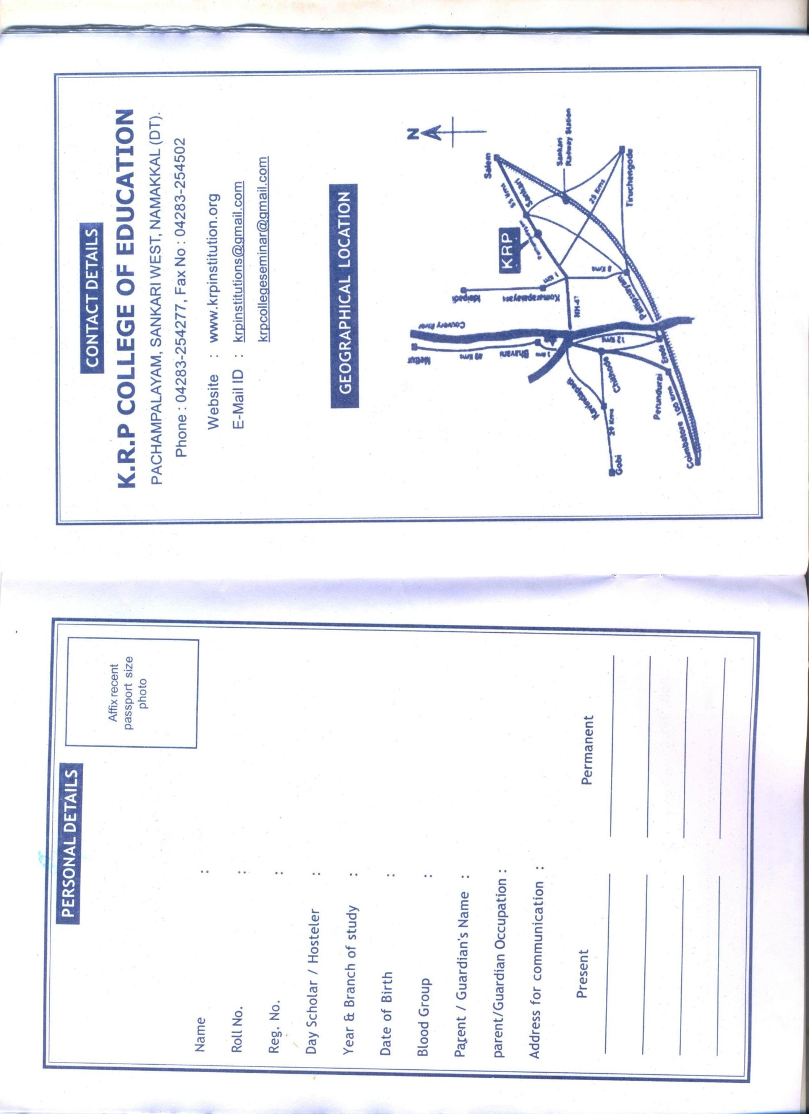
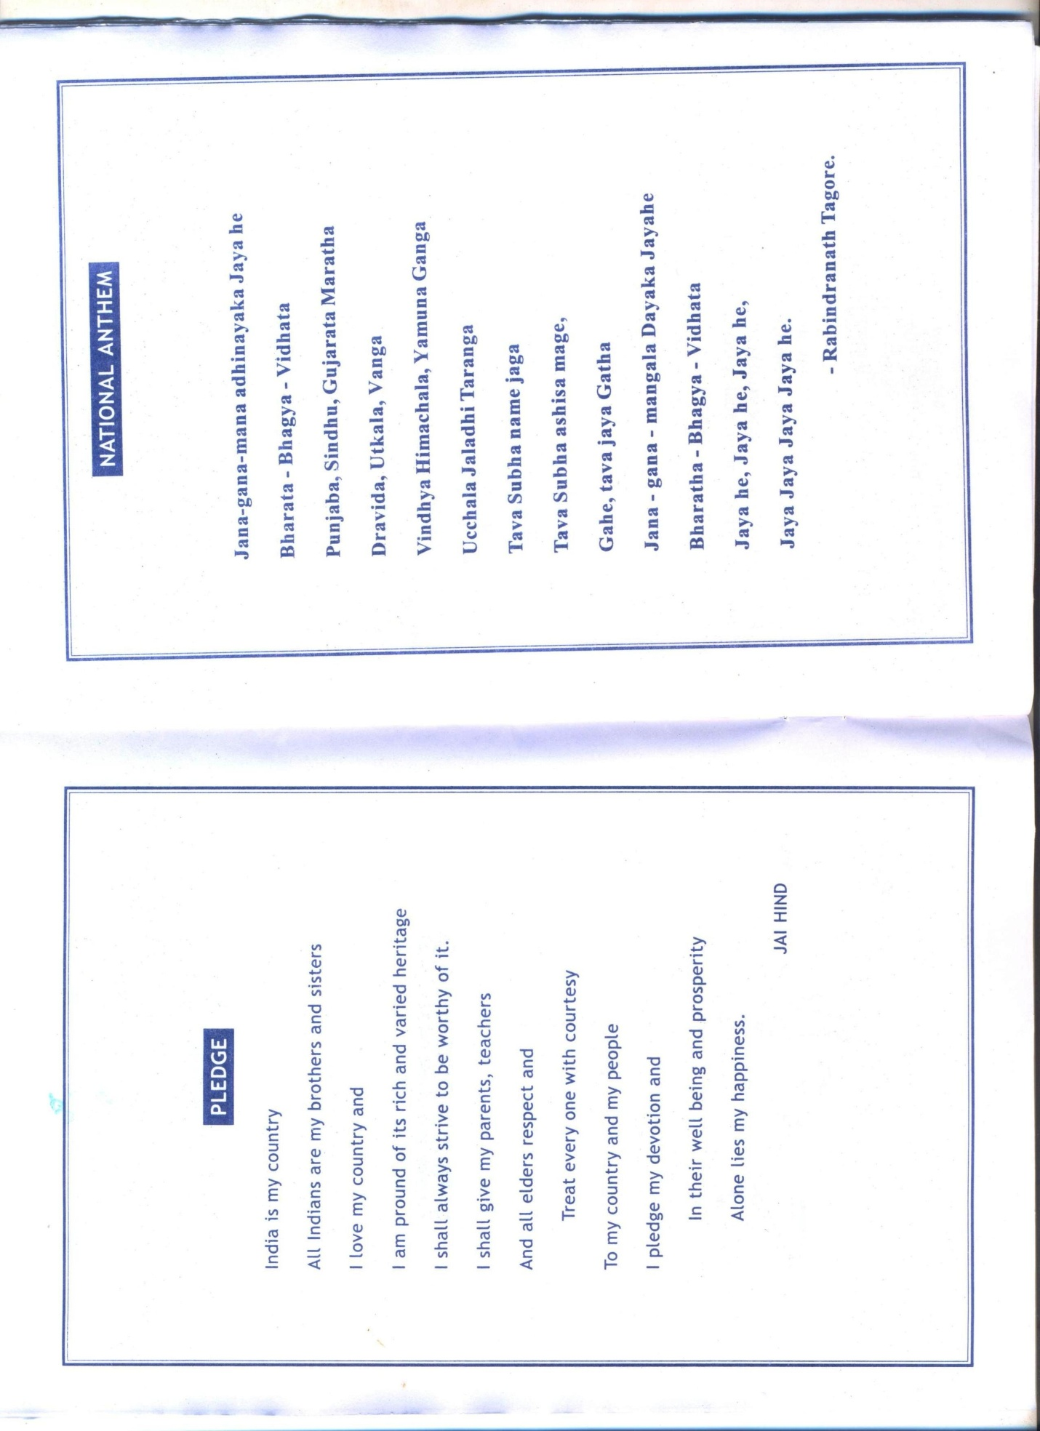

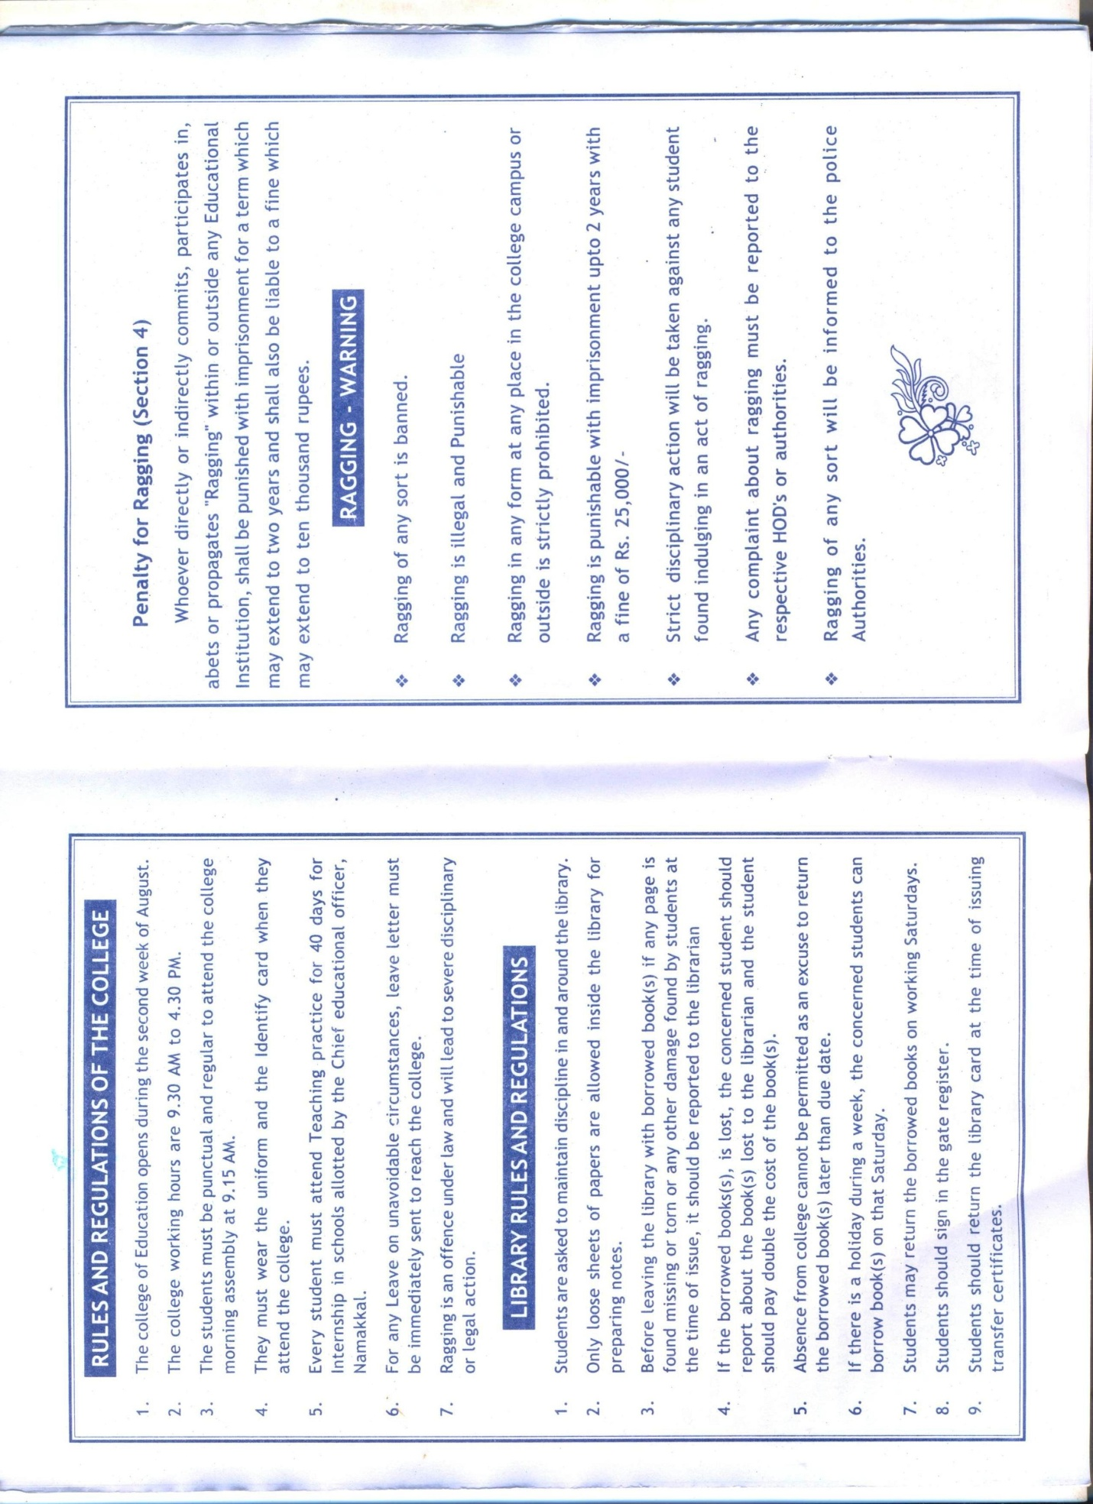



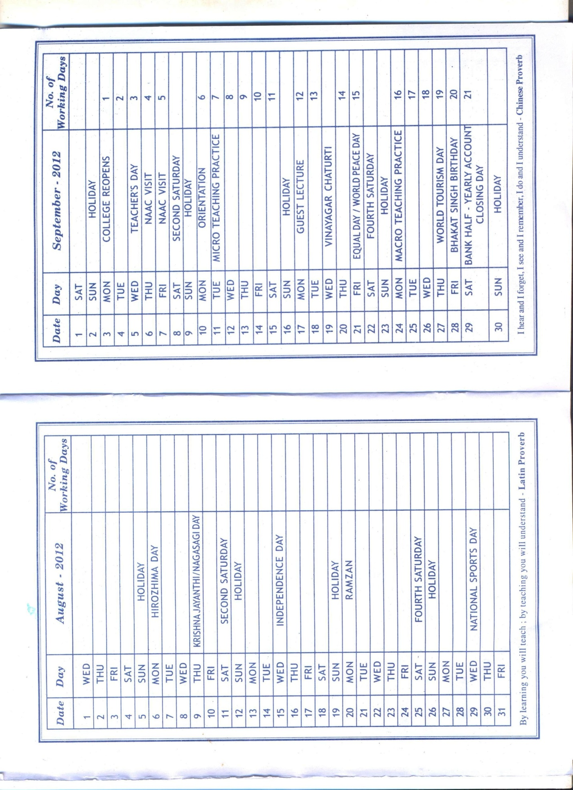
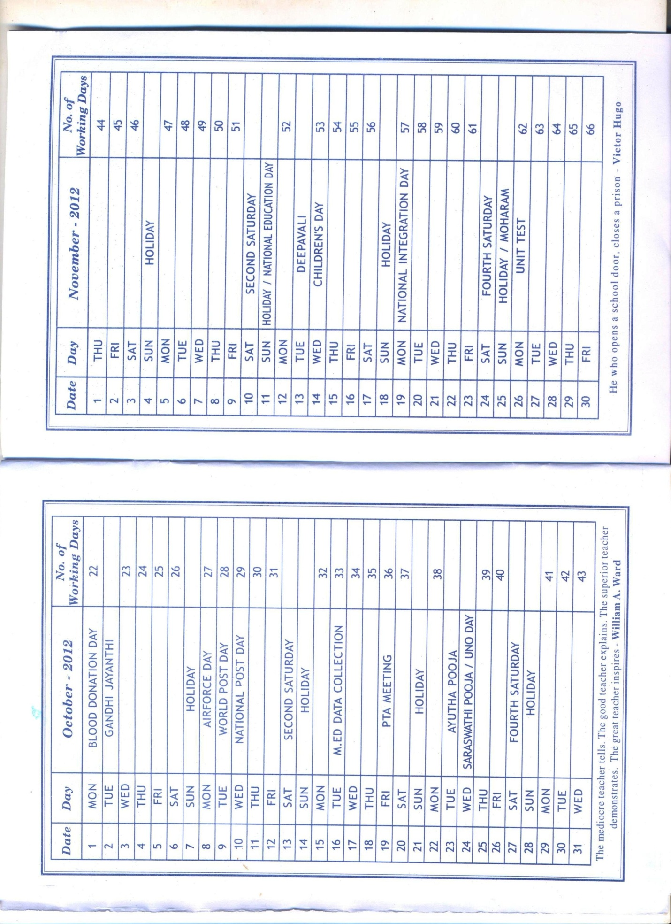
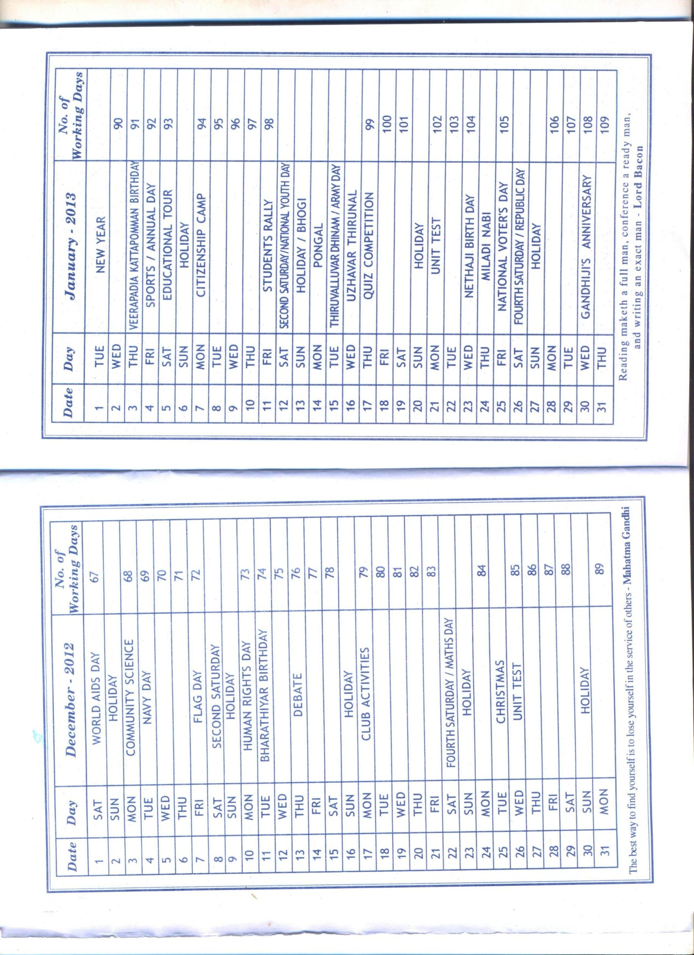
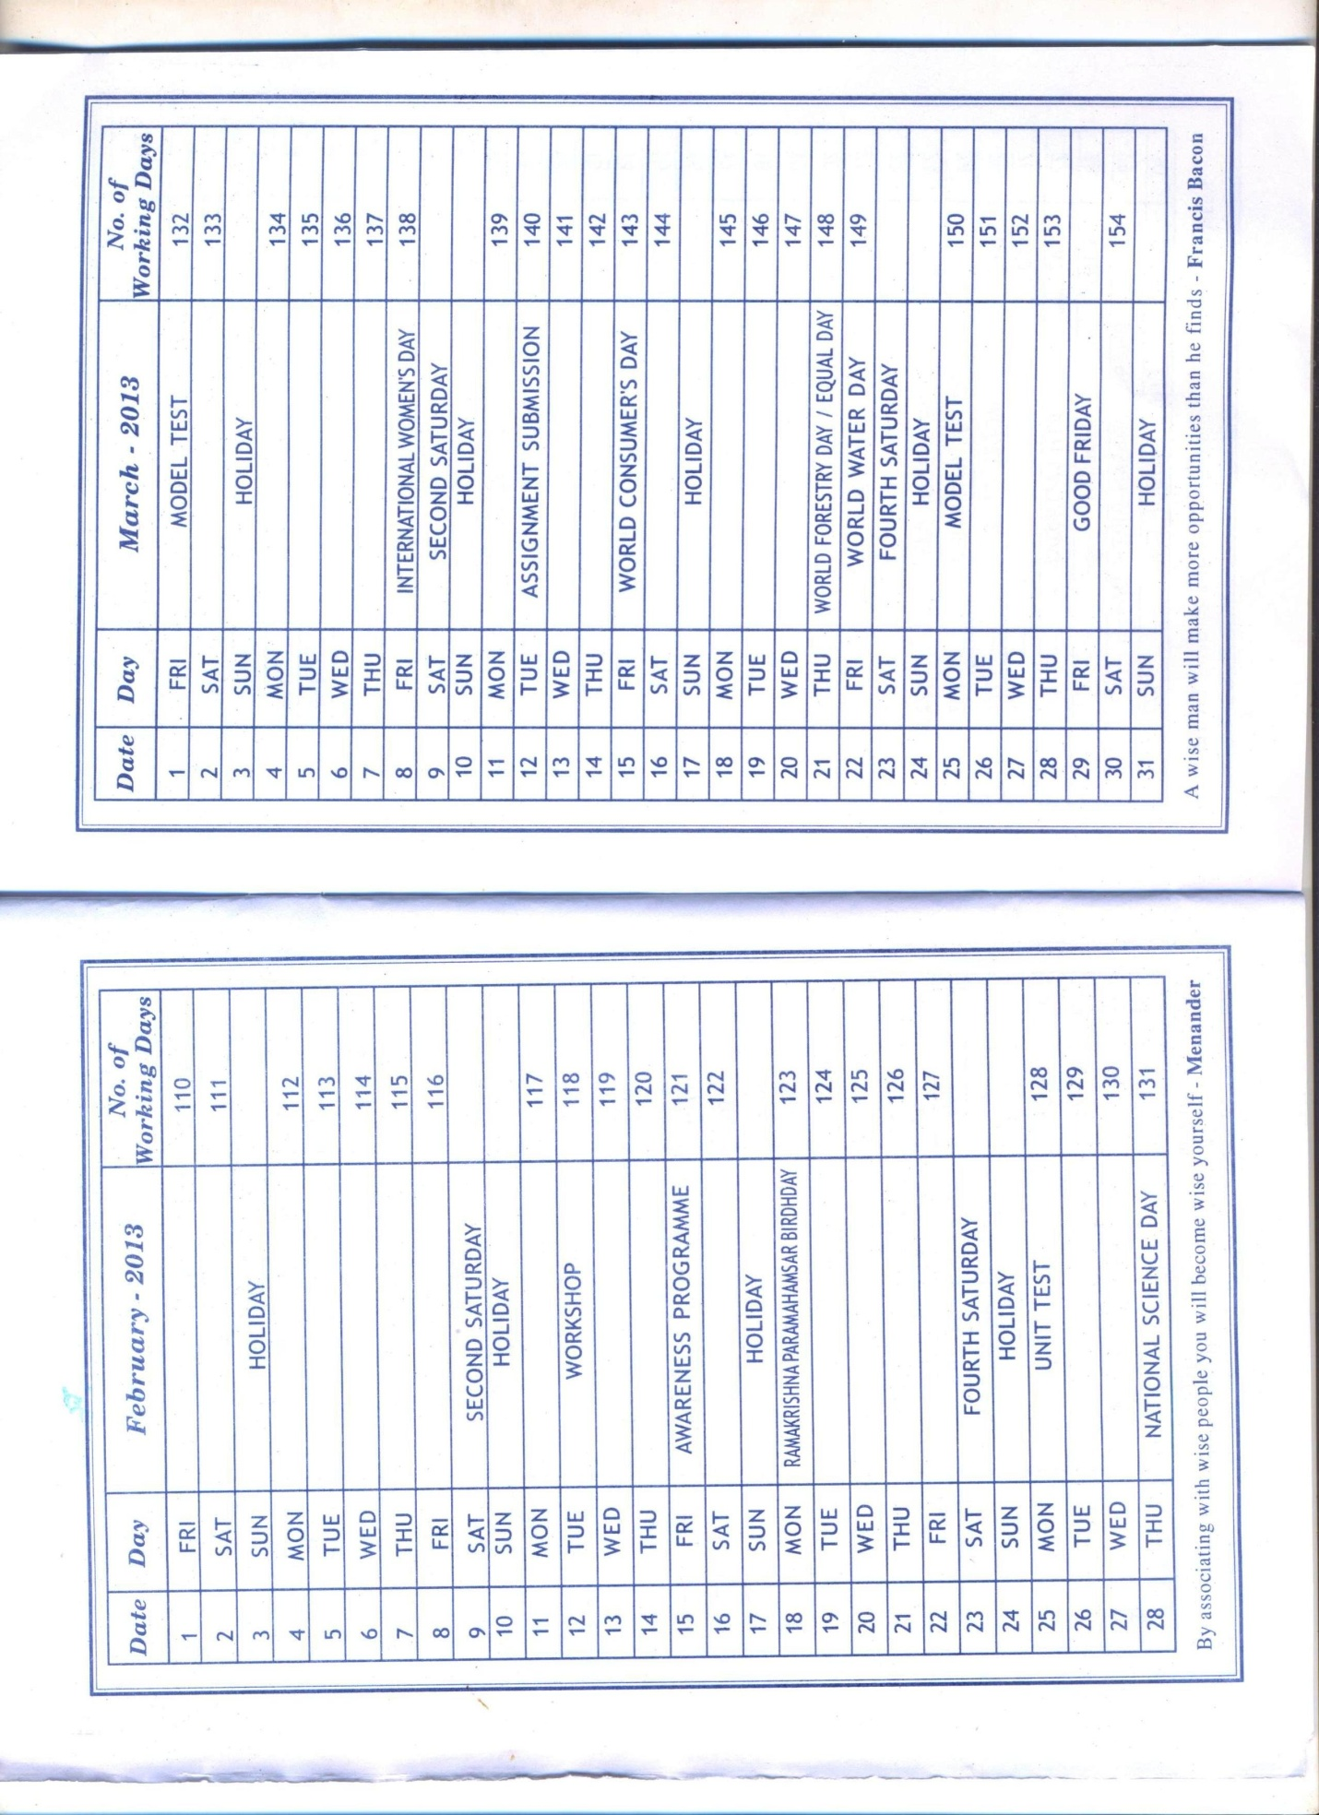

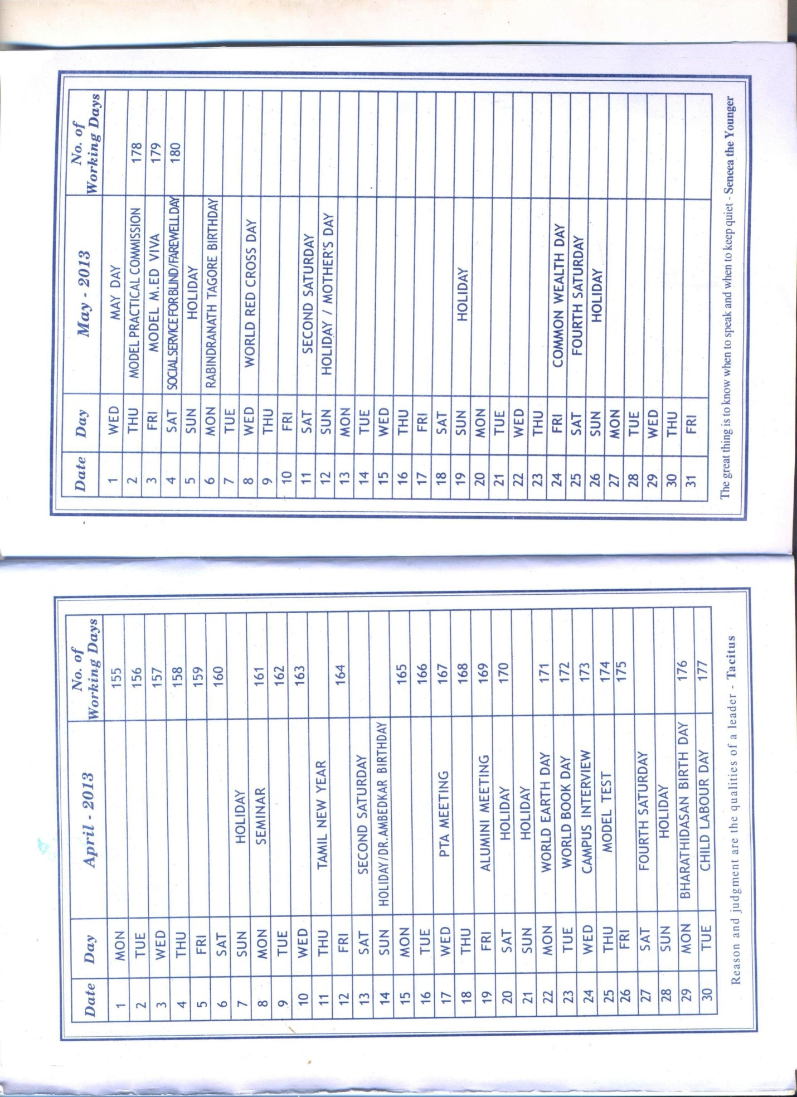

Annexure II
An Analysis of the feedback by various stake holders

The feedback of the parent teachers were to general in nature and didn’t touch any of the curricular and co-curricular aspects. They were only appreciating the regular functions in the college.
In the feedback of the alumni association, the alumni were appreciative of the students’ active participation in co-curricular and extracurricular activities. They have also expressed their views regarding the donations of the books to the library. Some of them have suggested the introduction of the Bridge course for improving communication skills.
The students’ feedback was obtained for all the faculties in the B.Ed course. The students have appreciated the efforts of the teachers in providing communication skill, learning materials and discussion of the topics. The students also have appreciated the lecturers for maintaining a good rapport with them and providing notes on the salient features of the topics.

Annexure III

OUR VISION

“Our College aims at the integral formation of

Prospective teachers to empower student-teachers to become

Responsible citizens and agents of social transformation”
Our vision is to develop the institution into a renowned center learning and knowledge. We also wish to make them useful citizens of the society contributing to their share, to the growth, welfare, and progress of Mother India. We also wish to shape the students with patriotism in their blood. We also propose to provide the best scope and opportunity to the students who involve themselves in the educational research and bring out the best in their effort.

OUR MISSION
The mission of our institution is provide the students with state of the art , techniques in teaching and learning and to equip them to function as dedicated teachers with a sense of world brotherhood. We also wish to provide right atmosphere and ambience for the teaching learning process and thereby to contribute to the technological advancement of the country.

OUR OBJECTIVES
- To promote love, purity and service
- To eliminate ignorance and illiteracy
- To impart education among rural students
- To develop National spirit and enhance universal brother hood
- To make Eco-friendly students.
- To develop Internal Quality Assurance Cell (IQAC)
- To strengthen the research and development cell

Annexure IV A
Best Practices [K.R.P.College of Education]
1]. LENDING TEACHING SERVICES OF EXTENSION TO NEAR BY INSTITUTIONS
Goal
To provide teaching services as a part of extension programme to nearby institutions during their course of study.
The context
It is necessary to encourage the students to teach in nearby schools where there is lack of teachers for some subjects. In order to promote their teaching proficiency, the B.Ed., teacher trainees of K.R.P. College of education lent their teaching service to the nearby govt schools.
The practice
B.Ed teacher trainees of 2012-13 batch were informed to handle classes from V std to IX std in nearby govt schools as one of their pre-service training. Interested and willing students were asked to take classes from V std to IX std either in the morning before the school starts or in the evening after the school hours. The trainees were also asked to take class on Saturdays also. This is one of the extension programmes of the B.Ed course.
Efforts were made to look after that the teacher trainees to handle the classes in a rotational way. one of the teaching faculty was given in charge to look after this extension programme.
Before taking classes the trainees were asked to collect the syllabus from the respective schools and also the trainees were motivated to take the class in different methods of teaching according to the concepts along with the teaching aids in order to capture the attention of the students.
The trainees were asked to take class mostly for maths, science and English, only for IX std social science was also handled. VI and VII STD, tamil and science classes were taken 15 teacher trainees participated in this programme.
Evidence of success
After finishing the classes the trainees were congratulated for taking classes excellently and for motivating the students to do their home work then and there, and for encouraging the students to read the news in the assembly and also for doing mini projects according to their interest in groups by the respective school head masters.
The teacher trainees also enjoyed this pre service training as one of the extension programme in the B.Ed course. Though the teacher trainees have undergone 40 days teaching practice, this training also added one more credit to their teaching proficiency.

Problems encountered by the teacher trainees
Some of the teacher trainees experienced lack of time when they were given unit test in the college as they had to prepare for both. Extra times were provided to the students to prepare and write the unit test and they were able to do it.

Annexure IV B

Best Practices [K.R.P.College of Education]
2].TALENT SEARCH PROGRAMME
Goal
To develop an action plan for the academic year 2012-2013. To find out the talents of individual students studying in B.Ed.course.
The context
At the institutional level, it is necessary to create a positive attitude, motivating the students to express their talents or skills in different programmes. This will provide support to the colleges for organizing co-curricular activities, promoting individual talents and also providing training in order to participate or take part in many competitions outside the college.
The practice
1. Staff members were informed to announce about the programme to be conducted for the talent search programme.
2. All the students were motivated by the teaching faculty members to participate in the programme according to their interest and skills. The students enthusiastically participated in these programmes.
3. Efforts were made to conduct the programme, and each faculty member was given incharge for each programme. The principal was assigned to co-ordinate for the programmes. The programmes conducted for the individual talent search programme were
a. Kavithai
b. Solo signing
c. Aural competition
d. Musical Instruments
e. Rangoli/Kola potti – for girls
f. Mehandi - for girls
Evidence of success
More than 80 students participated in these programmes and indicated their talents. The students were encouraged by giving prizes to first three places and they were also motivated to take part in the forth coming competitions outside the campus also.

Problems encountered and resources required
While selecting the students under each programmes we faced a few difficulties in identifying them. We got over the problems by making the students demonstrate the skills in the presence of the select committee.

